**Year 10IT: HTML 5 Programming Unit**

Sign up to an account using your school email address on the w3schools website. <https://profile.w3schools.com/log-in?redirect_url=https%3A%2F%2Fmy-learning.w3schools.com>

Select “HTML Tutorials”, read and study the tutorials from “HTML Basics” to “Formatting”

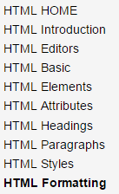

Note: Use the “Try it yourself” button to see the effect of the code in each section, and complete the quizzes to check your understanding.

**Exercise 1 – A bit about yourself**

Learning Task: Using notepad++, create an HTML webpage called ***aboutMe.html*** and save it on the “**HTML**” folder within your “**10IT**” folder. Ensure that you have the correct tags, elements and attributes to display the following features on your web page:

* A heading, with a color change
* At least 2 paragraphs
* Use of bold, italics and underline
* Changing text color
* Displaying title on the browser tab

Once your web page is finished, show me, so I can mark it off.

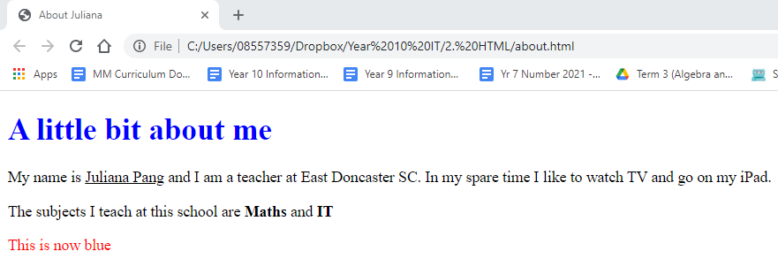

**Exercise 2 – Inserting images**

We are going to add 3 images to your web page. The three images will be saved in different locations compared t*o* the location of the file *aboutMe.html*.

1) Open up the web page *aboutMe.html.* Add the following code to display an image saved on the same folder as your HTML file (i.e. HTML folder.). You can either use the images given on the Class Resources – HTML Resources – Images folder, or find your own, just change the image name in the following code from “sunset” to the name of your image.

<IMG SRC="sunset.jpg">

2) To display an image saved on a sub-directory (level down), use the following code. The image *elmo.jpg* is saved on a sub-directory called *images* within the *HTML* folder.

<IMG SRC="images/elmo.jpg">

3) To display an image saved on a directory that is one level up, use the following code. The image called *dog.png* is saved on the “*10IT*” folder that is above the *HTML* folder. Remember to replace the two dots before the forward slash with the path to the image file. (I will show you how to copy the path in class.)

<IMG SRC="../dog.png">

4) To resize an image, use the width and height attributes. The following is a snippet of how your images should look like.

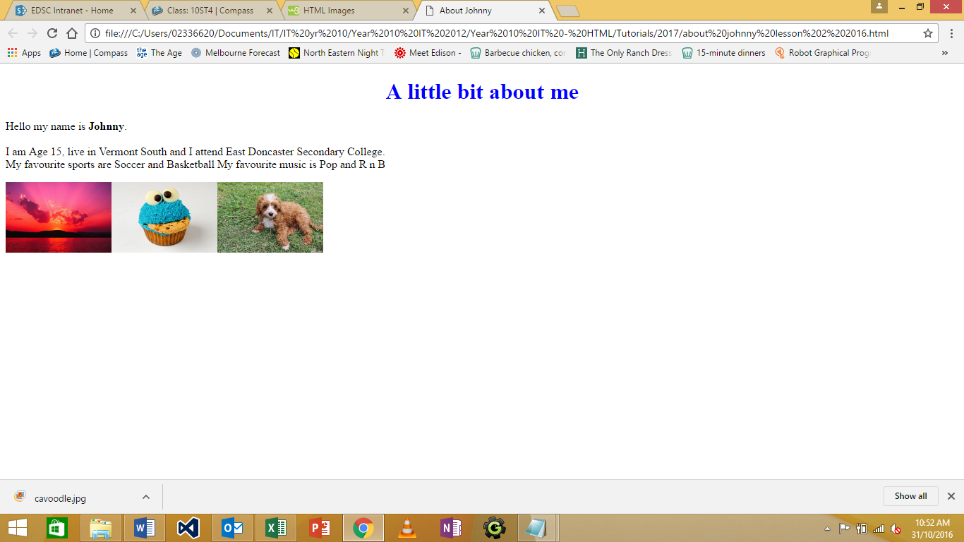

Your Task: Update *aboutMe.html* and show me. You need to ensure that there is at least 3 pictures, resized, and located in three different places within your 10It folder.

**Exercise 3 – Inline CSS (cascading style sheets)**

Complete the following tutorials on the w3schools website.

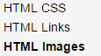

Learning Task: Create a new page, *favourite.html,* using notepad++and show me. This is just a short page detailing one of your favourite things. Have a heading, a short paragraph, and a picture.

* Ensure that you have the correct tags, elements and attributes.

* Change the size and colour of the font by using the **Inline Cascading Style Sheets (CSS) method,** by using the **style** attribute inside the HTML tags.

E.g. <h1 style=”color:blue;”> My Favourite cartoon character </h1>

* You may also change the background colour of the page, the location of the pictures, and set up page formatting using CSS.

*favourite.html*

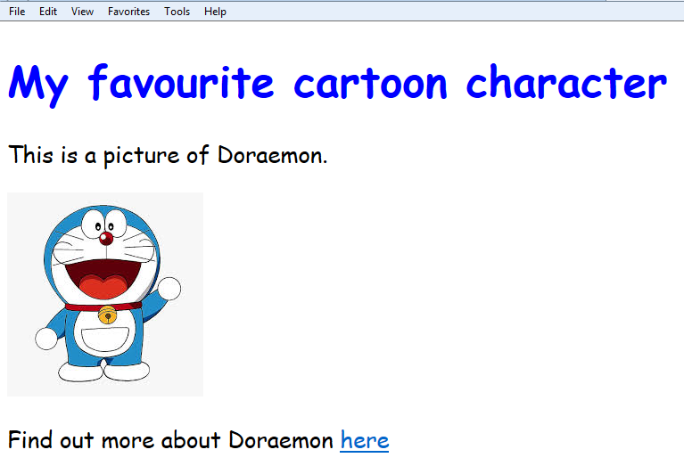

**Exercise 4 – Ordered and unordered lists**

In this exercise, we are going to make a new web page titled “My Timetable”. You will add an unordered list of the subjects you do at EDSC to this page and an ordered list of 3 external website links.

**Steps:**

1. Create a new html page called *timetable.html* by opening a new notepad++ file again. Save it on the same folder as before.
2. To change the browser tab title to read “My timetable” as shown below, you will use the <title> tag within the tag pair <head> and </head>. (See the sample code below.)

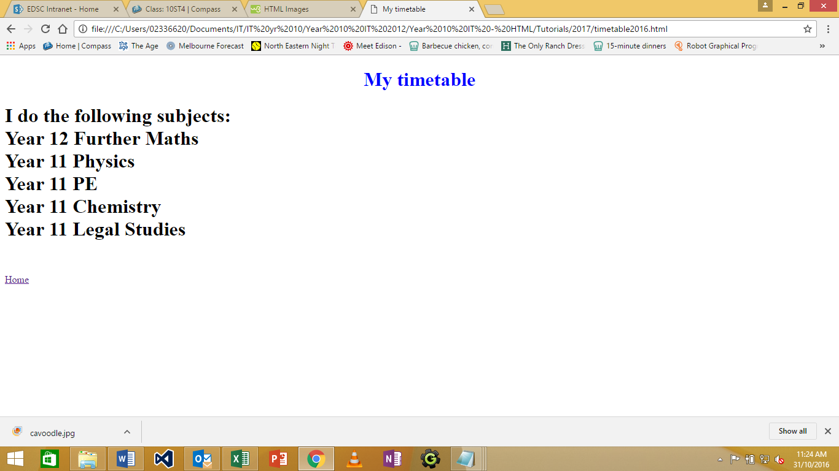

* Year 11 Legal Studies
* Year 10 Pre Methods
* Year 10 English
* Year 10 Analytical Science
* Year 10 IT
* Year 10 Geography
* Year 10 PE
* Year 10 Media

1. To insert an unordered (bulleted) list, you will use the <ul> tag and to insert each list item, you will use the <li> tag as shown below.

<!DOCTYPE html>

<html>

<head>

<title> My Timetable </title>

</head>

<body>

<h1>My timetable at EDSC</h1>

<h2>I do the following subjects: </h2>

<ul>

<li> Year 11 Legal Studies </li>

<li> Year 10 Pre Methods </li>

<li> Year 10 English </li>

<li> Year 10 Analytical Science </li>

<li> Year 10 IT </li>

<li> Year 10 Geography </li>

<li> Year 10 PE </li>

<li> Year 10 Media </li>

</ul>

</body>

</html>

1. To insert an ordered (numbered) list, you will use the <ol> tag and to insert each list item, you will use the <li> tag as shown above.

Below the list of subjects, create an ordered list of web links (to websites of your choice).

At the first list item, insert a link to an external web site as follows:

<a href=”http://[www.google.com](http://www.google.com)”> Google </a>

Then at the next 2 list items, add links to two more external websites of your choice.

**Can you try to embed a hyperlink in an image?** (Click on the image to load the website.)

1. Finally, add an internal link to your *timetable.html* page by inserting the following line in *Aboutme.html* page, somewhere in between the <body> and </body>.

<a href=”timetable.html”> My Timetable </a>

Now insert an internal link on timetable page back to your original page.

<a href=”AboutMe.html”> Home </a>

**Exercise 5 - Tables**

A table is a way to summarise data.

You can customise a table to include exactly the number of columns and rows that your data requires. You also can modify a table’s structure so that one or more cells are part of multiple row or columns. The cells’ border colour, thickness and visibility can also be altered.

A table is divided into rows (going across) and columns (going down):

|  |  |  |
| --- | --- | --- |
| **cell** |  | **row** |
|  |  |  |
|  |  |  |

**column**

The main tag pair for creating a table is **<table>…</table>**

To add a row, use **<tr>…</tr>**

To add a new cell within a row, use **<td>**

The first row in most tables usually use a **<th>**

This is short for table header. The <TH> formats the contents of a cell as centred and boldface, making the column headings stand out from the contents of the cells below them.

Change the personal information on the “aboutme” page to look like this. The code to use is below

|  |  |
| --- | --- |
| Age | 14 |
| Suburb | Doncaster East |
| School | EDSC |
| Favourite Sport | Soccer |
| Favourite Music | RnB |

The following code is used:

<TABLE BORDER=“2”>

<TR>

Adds a border around the table and each cell; the value determines the thickness of table border. A value of 0 means no visible border.

<TD>Age

<TD>14

</TR>

<TR>

<TD>Surburb

<TD>Vermont South

</TR>

<TR>

<TD>School

<TD>East Doncaster Secondary College

</TR>

<TR>

<TD>Favourite Sport

<TD>Soccer, Basketball

</TR>

<TR>

<TD>Favourite Music

<TD>Pop, R n B

</TR>

</TABLE>

Let’s make a timetable now for the subjects you are taking at school. We will be updating the *timetable.html* page. The end product should look something like this. The following table is 7 rows <TR>, and each row contains 6 cells <TD>:

**The cells here are colored for easier reading**

**The headings here are bold using <TH>**

|  |  |  |  |  |  |
| --- | --- | --- | --- | --- | --- |
|  | **Mon** | **Tues** | **Wed** | **Thu** | **Fri** |
| **Period 1** | English  BLA, Rm 505 | IT  PAN, Rm 103 | Sport Ed  - | Chinese  LIN, Rm 516 | Maths  VEL, Rm 104 |
| **Period 2** | Maths  VEL, Rm 104 | Geography  BEE, Rm 526 | Maths  VEL, Rm 406 | English  BLA, Rm 505 |
| **Period 3** | History  WIL, Rm 501 | English  BLA, Rm 505 | IT  PAN, Rm 103 | English  BLA, Rm 505 | PE  CAM, hall |
| **Period 4** | History  WIL, Rm 501 | Geography  BEE, Rm 526 |
| **Period 5** | Geography  BEE, Rm 526 | Materials Tech  PHA, Rm 303 | Chinese  LIN, Rm 518 | IT  PAN, Rm 103 | Chinese  LIN, Rm 518 |
| **Period 6** | IT  PAN, Rm 103 | Maths  VEL, Rm 104 | Maths  VEL, Rm 104 |

**These cells here are merged using ROWSPAN.**

**Text at the side is bold**

Learning Task:

1. Open up **timetable.html** that you started previously. The table will fit in here.

<HTML>

<HEAD>

<TITLE>My Timetable</TITLE>

</HEAD>

<BODY>

<H1>My Timetable - Semester 1 - 2017</H1>

**<TABLE>**

**</TABLE>**

**The table’s rows and columns will go here**

</BODY>

</HTML>

2. Think about how you are going to create the timetable above. If you need to, first jot down on paper how the <TR> and <TD> needs to be laid out. For example, refer to the diagram and the code for the **spanned rows** table below. You can also experiment with the <TR> and <TD> in your file, timetable.html until you get the desired result.

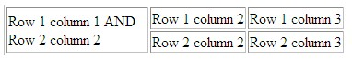

<TABLE border="1">

<TR>

<TD ROWSPAN="2" WIDTH="150">Row 1 column 1 AND Row 2 column 2

<TD>Row 1 column 2

<TD>Row 1 column 3

</TR>

**Here we allocated this cell to span over two rows. We also specified the width of the cell by WIDTH=“VALUE”**

<TR>

<TD>Row 2 column 2

<TD>Row 2 column 3

</TR>

</TABLE>

3. To change the **row** colours, you need to apply the following code to <TR>:

<tr bgcolor=grey>

You may also use the same method to change the colour of individual <TD> cells. The task for you is to colour code your timetable, allocating a colour for each subject.

Learning Task:

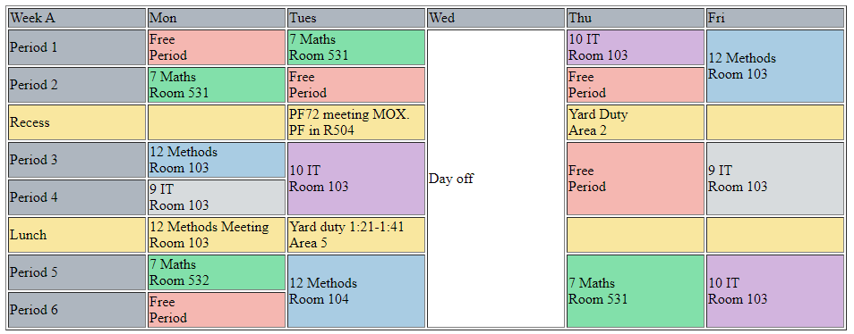

Create **both weeks A and B of your timetable**. Once done, print out your timetable in colour and hand it into your teacher.

5. Save your file. To make a hyperlink to your timetable page from your main page (*aboutMe.html*), you need to add in the following code underneath the list of subjects you are taking:

<p> To view the timetable for the subjects I am taking, please press <a href=”timetable.html”>here</a>. </p>

This creates a hyperlink - so when the user clicks on “here”, the browser would open up to the timetable page. Save both your files.

**Exercise 6 – Hexadecimal code for colors**

Complete the following tutorials on the w3schools website.

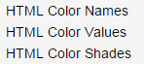

Colors are defined using a hexadecimal (hex) notation for the Red, Green, and Blue values (RGB). The lowest value for each light source is 0 (hex 00). The highest value is 255 (hex FF).

Hex values are written as # followed by three or six hex characters.

Three-digit notations (#rgb) are automatically converted to six digits (#rrggbb).

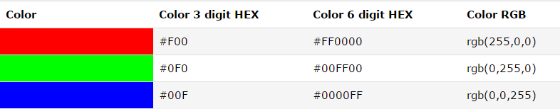

Black can be considered as the absence of any red, green or blue (hence the #000000) and white is the presence of all 3 primary colors.

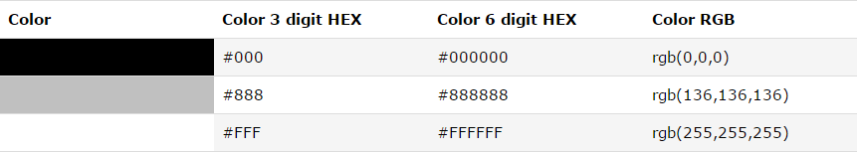

You can alter each digit from 0 to F to get any color in between:



The colors can be changed by adding an attribute to tags, for example:

<p style="color:red">

<td bgcolor=#008080>

<p style=”color:#008080”>

Note how some colors have a shortcut – you can use the word “red” instead of typing out #FF0000. There are 140 of these color words – you can see the whole list here:

<https://www.w3schools.com/colors/colors_names.asp>

Learning Task:

Create a new page called Colours.html in the same folder as the AboutMe.html page.

Using your knowledge of colours, produce the following colour swatch

(Hint: First create a table with 9 rows, 8 columns)

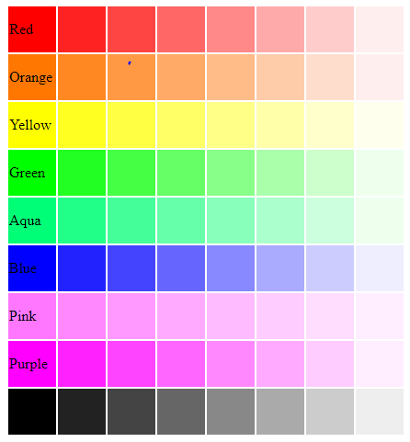

**Exercise 7 – More CSS methods**

To align text and images in HTML 5, you need to use CSS or **Cascading Style Sheets**. You can learn more about CSS by referring to the following link: <https://www.w3schools.com/html/html_css.asp>

For this task, open up the previous CSS work that you have done (on your **favourites.html** page), and add the following elements.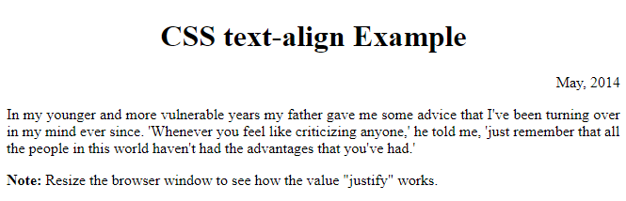

The **Internal CSS** code for the above page is as follows. Note how the <style> tag pair is used within the <head> tag pair. You should try to write the curly brackets in the same position as shown below:

<!DOCTYPE html>

<html>

<head>

<style>

h1 {

text-align: center;

}

p.date {

text-align: right;

}

p.main {

text-align: justify;

}

</style>

</head>

<body>

<h1>CSS text-align Example</h1>

<p class="date">May, 2014</p>

<p class="main">In my younger and more vulnerable years my father gave me some advice that I've been turning over in my mind ever since. 'Whenever you feel like criticizing anyone,' he told me, 'just remember that all the people in this world haven't had the advantages that you've had.'</p>

<p><b>Note:</b> Resize the browser window to see how the value "justify" works.</p>

</body>

</html>

# Create a new HTML page called “CSS Images” and use Internal CSS to complete the following:

# 

<!DOCTYPE html>

<html>

<head>

<style>

First, the width is set to 50%. This is 50% of the browser window’s width. The margin-left and margin-right to auto will set it to centre.

img {

display: block;

margin-left: auto;

margin-right: auto;

}

</style>

</head>

<body>

<h2>Center an Image</h2>

<p>To center an image, set left and right margin to auto, and make it into a block element.</p>

<img src="paris.jpg" alt="Paris" style="width:50%">

</body>

</html>

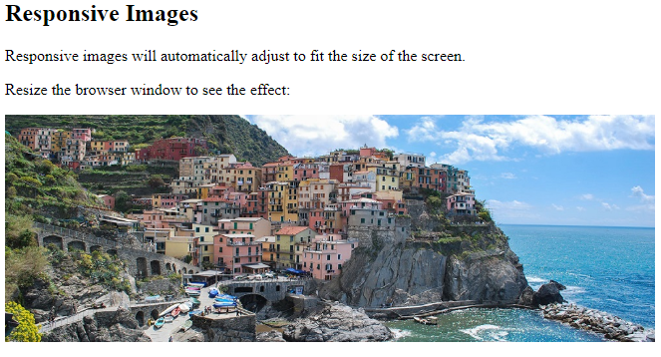

<!DOCTYPE html>

<html>

Notice how the width of this image is set to 1000 pixels. However, in the CSS section, we then set max-width to be 100%. This will check how wide the browser is and loads your image accordingly. The height is set to auto so it doesn’t distort your image.

<head>

<style>

img {

max-width: 100%;

height: auto;

}

</style>

</head>

<body>

<h2>Responsive Images</h2>

<p>Responsive images will automatically adjust to fit the size of the screen.</p>

<p>Resize the browser window to see the effect:</p>

<img src="img_5terre_wide.jpg" alt="Cinque Terre" width="1000" height="300">

</body>

</html>

**Extension:**

Go to the page CSS3 Images to learn more about styling images beyond alignment.

<https://www.w3schools.com/css/css3_images.asp>